‘X’ Option for Legal Sex and Sex Assigned at Birth: Epic Tip Sheet and Responding to Patient Concerns

“X” will be added as an option for selection in the Legal Sex and Sex Assigned at Birth fields in Epic beginning December 15. If a patient has X listed as their sex on their state or government IDs, you can select X as their legal sex. If a patient has X listed as their sex on their birth certificate, you can select X as their sex assigned at birth. These fields should only be changed if a patient has X or nonbinary listed on these official records.

What is X?
X is a response option on government identification documents (such as driver’s licenses, passports and birth certificates) that designates a legal sex other than male or female. Most commonly, people who are intersex, transgender or nonbinary may opt to use X on their identification papers.

Why is Northwestern Medicine updating Epic to include X?
Having this option supports the health and care of nonbinary, intersex and transgender patients.

Current Legal Sex Categories | Updated Legal Sex Categories (as of December 15, 2023)
Male  Female  Unknown | Male  Female  X  Unknown

Current Sex Assigned at Birth Categories | Updated Sex Assigned at Birth Categories  (as of December 15, 2023)
Choose not to disclose  Male  Female  Not recorded on birth certificate  Uncertain  Unknown | Choose not to disclose  Female  Male  X  Not recorded on birth certificate  Uncertain  Unknown

Epic Tip Sheet: Entering Patient Legal Sex, Pronouns and Preferred Name at Registration
Legal Sex
When collecting patient demographic information, registrars should enter the sex indicated on a patient’s identification document(s) into the “Legal Sex” field shown in Demographics below:
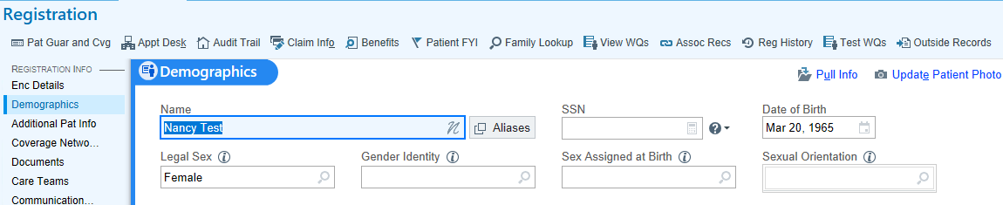

If verbally collecting legal sex, registrars can ask one of these two questions:
- “What is your legal sex?”
- “What sex do you have listed on your driver’s license or passport?”

Sex Assigned at Birth
Patients may request to have their sex assigned at birth updated during registration, in which case you may update this information in the “Sex Assigned at Birth” field in the Demographics screen shown above. If verbally collecting sex assigned at birth, registrars may ask:
- “What sex is listed on your birth certificate?”

Pronouns and Preferred Name
It is best practice to confirm personal pronouns and preferred name for every patient. A patient’s preferred name or pronouns may not match what is recorded on their identification documents. When collecting patient demographic information, registrars may ask questions like these:
- For preferred name:
  - “What name do you go by?”
  - “What name would you like us to use when addressing you?”
  - “Is there another name you like to be called other than your legal name?”
- For pronouns:
  - “What pronouns do you use?”
  - “Would you like to designate your personal pronouns?”
  - “My name is [Maria], and I use [she/her] pronouns. May I ask which pronouns you use?”

Preferred name can be entered in the “Name Edit” window. To access this window, click on this icon in Demographics:

Then, enter their preferred name in the Preferred name field:
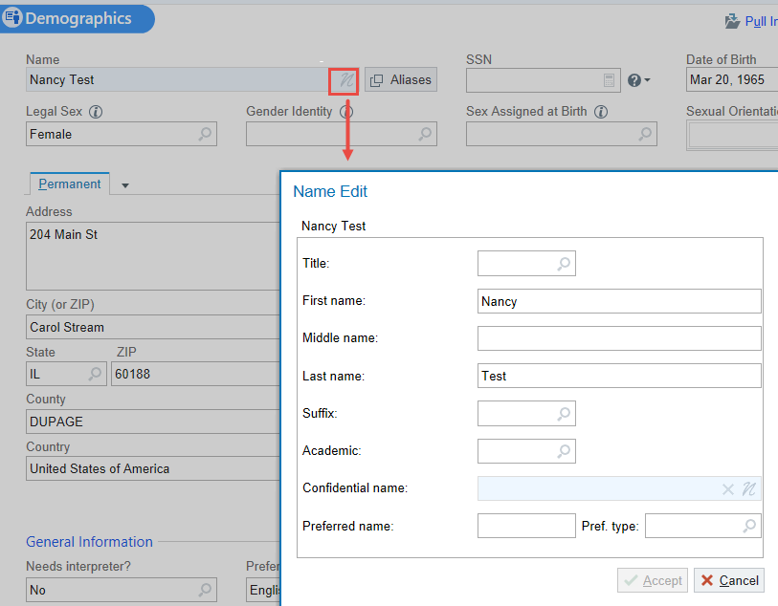

Pronouns can be entered in the “General Information” section in Demographics:
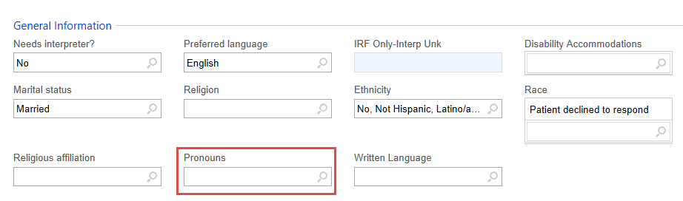

Responding to Patient Concerns About Legal Sex, Pronouns and Preferred Name
Patient Concern | Response
“Why are you collecting this information?” | “We want to make sure that we are able to identify and address all of our patient’s needs. It’s part of ensuring that all of our patients receive the highest quality of care.”
“Who will see this information?” | “This information is confidential. The only people to see this information will be members of your care team and those who are authorized to see your medical record.”
“Why are you asking for my preferred name or pronouns?” | “We want to be sure we correctly address all of our patients. Asking this information of everyone helps us get it right.”
"I'm obviously a [man/woman]. Why are you asking me this?" | “These are questions we ask every patient. We just want to make sure our records are correct. Let’s move on to make sure the other information we have on file for you is right.”
“You used the wrong pronoun for me.” | “I’m sorry. Could you please remind me what pronouns you use?”

